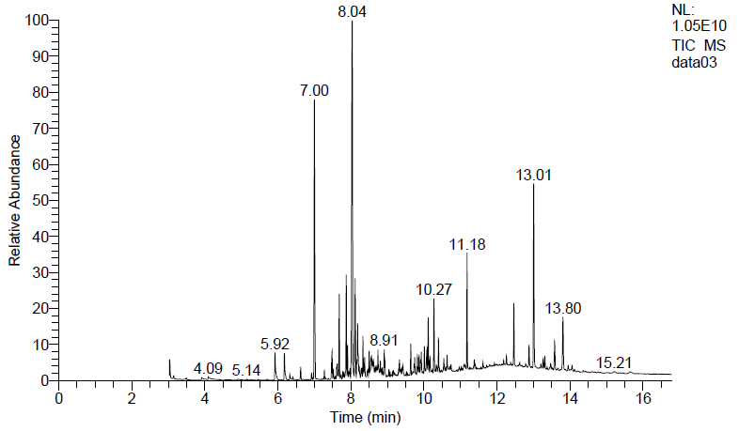

**Figure 1. GC–MS analysis to detect anti-cancer compound in *C. gileadensis* extract.**